Sending a contribution allocation file in the correct format is required for processing. See the “File Format Instructions” section below for detailed instructions. The contribution allocation file includes the account number, or Social Security Number, amount of deposit, and contribution type (employee or employer and current year or prior year). If an employee has one deposit for each contribution type, each contribution must appear as a separate line item. Sending an allocation file with errors may cause your file to be delayed.

**File Format Requirements**

Contribution allocation files must be sent in Comma Separated Values (.csv) format. Any other format will result in a failed validation. A record is required for each contribution. The very first record will contain text headings that describe the data being submitted.

Important Note: To create a .csv file, an Excel document needs to be saved in .csv format. This is done by selecting File, ‘Save As’ and selecting .csv when prompted for ’save as type.’ The screen shot below depicts this option being selected. Multiple prompts may appear to verify that this save option is selected. Select ‘Yes’ or ‘Okay’ for all prompts. Please note that this should be the .csv (Comma Delimited) format and not the csv (MS-DOS).



**Field Format Instructions**

There are 4 fields in the contribution allocation file that are required by Optum Bank. Fields 1, 3 and 4 must be populated for each transaction. Either the Account Number (Field 2) or Social

Security Number (Field 5) or both must be populated for each transaction. Whether populating the Social Security Number field or the Account Number field or both, please always include all five column headings. All of these fields must be formatted according to the instructions below. Incorrect formats or the failure to include any of the required fields may result in incorrect or incomplete deposits to the individual HSAs or complete file validation failure. The ‘Field Header’ row must be included exactly as it appears below on all contribution files. **Please note that negative or zero value contributions cannot be accepted in the file.**

Specific field instructions are described on the following table:

|  |  |  |  |  |  |
| --- | --- | --- | --- | --- | --- |
| **Column** | 1 | 2 | 3 | 4 | 5 |
| **Field**  **Header** | Transaction Type | Account Number | Credit Amount | Contribution Type | Social Security  Number |
| Mapping Notes | Contribution | Leave blank | Sum (PdhEECurAmt) where eeddedcode = HSAI, HSAF, HSACI or HSACF | Current Year Employee Contribution | eepssn |
| Sum (PdhERCurAmt) where eeddedcode = HSAER | Current Year Employer Contribution |
| **Format** | Must contain the  12 character word:  Contribution    No spaces before or after the header text. | Numeric field of 9 digits  Wrap in quotes so leading zeros don’t drop off  No spaces before or after the header text. | Numeric dollar amount including cents without $  sign, negative (-) sign or decimal.  For Example:  $102.34 = 10234 $1.02 = 102  $102.00 = 10200    No spaces before or after the  header text. | Must use one of  4 Predefined  Contribution  Types (must use exact wording; see  Contribution  Type Values below).  No spaces before or after the header text. | Numeric field of 9 digits    No spaces before or after the header text. |
| **Length** | 12 characters | 9 digits | 1 to 11 digits | 34 characters | 9 digits |

1. **Current Year Employee Contribution**: This Contribution Type signifies funds being taken from an employee’s pay to go into their HSA. All funds deposited as Employee funds will be posted as pre-tax dollars.
2. **Current Year Employer Contribution**: This Contribution Type signifies the employer making the contribution into the account holders HSA.
3. **Prior Year Employee Contribution:** This Contribution Type signifies funds being taken from an employee’s pay to go into their HSA for the Prior Year.
4. **Prior Year Employer Contribution:** This Contribution Type signifies the employer making the contribution into the account holders HSA for the prior year.

The example below illustrates the correct appearance of the contribution allocation file in

Comma Separated Value (.csv) format.

The first example is if social security numbers are not provided. Note the Social Security Number header is included though the individual records under it are blank.

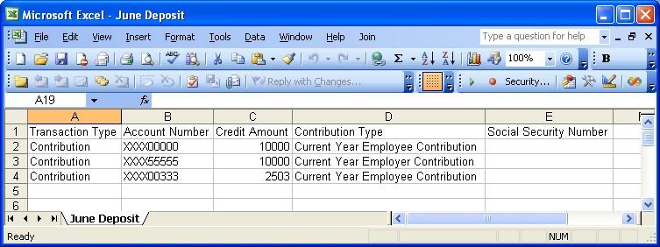

The example below is if social security numbers are provided. Note the Account Number header is included though the individual records under it are blank.

